Postal Life Insurance

Department of Post

Software Requirements Specification (SRS)/ Functional Requirements Specification (FRS)
Refund of Premium

INTERNAL APPROVAL FORM

Project Name: Refund of Premium
Version: 1.0
Submitted on:
 | Name | Date
Approved By:
Reviewed By:
Prepared By:

VERSION CONTROL LOG
Version | Date | Prepared By | Remarks
1

Table of Contents

1. Executive Summary 4
2. Project Scope 4
3. Business Requirements 4
4. Functional Requirements Specification 5
4.1 Non-Financial Service Request Indexing page 5
4.2 Duplicate Policy Bond Page 6
5. Attachments 6

1. Executive Summary
This document outlines the Software Requirements Specification (SRS) for the Refund of Premium module in the India Post PLI Insurance Management System (IMS 2.0). The objective is to digitize and streamline the refund process, replacing the current manual and paper-based system with an automated, transparent, and efficient digital workflow.

2. Project Scope
The Refund of Premium module will enable customers to request refunds for premium payments made erroneously. The system will automate validation, computation, and disbursement of refunds, integrating with financial systems such as NEFT, POSB, and IPPB.

3. Business Requirements

ID | Requirements
FS_ROP_001 | System shall allow customers to submit refund requests digitally.
FS_ROP_002 | System shall compute refund amount with applicable GST/TDS rules.
FS_ROP_003 | System shall disburse refunds via NEFT, POSB, or IPPB.
FS_ROP_004 | System shall notify customers of refund status at each stage.
FS_ROP_005 | System shall maintain a complete audit trail of all refund transactions.

Refund of premium process:
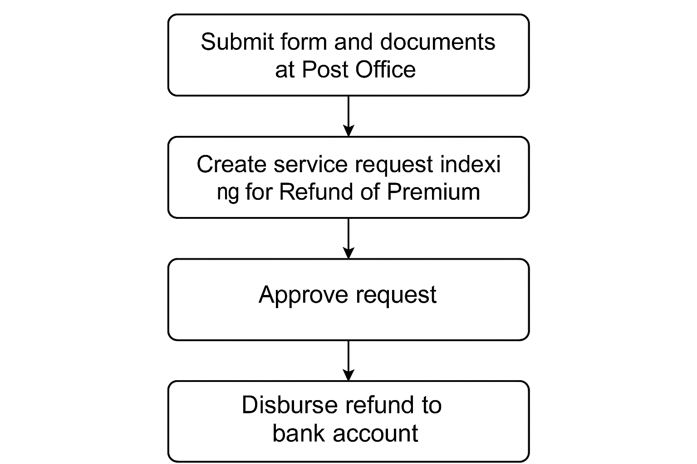

4. Functional Requirements Specification

4.1 Non-Financial Service Request Indexing page
- Purpose: To create Service Request for Refund of Premium.
- Fields:
  - Service Request Date: Calendar: Date on which service request is indexed.
  - Policy Number: Text
  - customerId: Unique ID of the customer (e.g., CIF or Aadhaar-linked ID).
  - refundReason: Reason for requesting the refund (e.g., duplicate payment, wrong deposit).
  - paymentDate: Date on which the premium payment was made.
  - paymentAmount: Amount paid by the customer.
  - paymentMode: Mode of payment used (e.g., Online, POSB, IPPB, Cash).
  - receiptNumber: Receipt or transaction ID associated with the payment.
  - bankAccountNumber: Customer’s bank account number for receiving the refund.
  - ifscCode: IFSC code of the customer’s bank branch.
  - bankName: Name of the bank where the refund will be credited.
  - accountHolderName: Name of the account holder as per bank records.
  - supportingDocuments: Optional documents such as payment proof or cancelled cheque (usually in Base64 or as a file URL).
  - remarks: Any additional comments or notes related to the refund request.
  - Office Code: Text: Facility ID of the office where request is getting indexed
  - Service Request Channel: Text: Channel for the service request like RICT, CP etc.
  - Username: Text: Emp ID of the user indexing the request
- Rules:
  - Request should get created and CPC User should be able to open the details.
  - Automatic Payment should be processed once the request got approved by CPC User in the bank account details provided by customer.

5. Attachments
The following documents can be referred.

